**Name: VISHNU SADASIVAN**

**Roll No:52**

**Batch: B**

**Date:06-04-2022**

**NETWORKING & SYSTEM ADMINISTRATION LAB**

**Experiment No.: 1**

**Aim**

Introduction to hardware components.

**Procedure**

#### 1.MOTHERBOARD

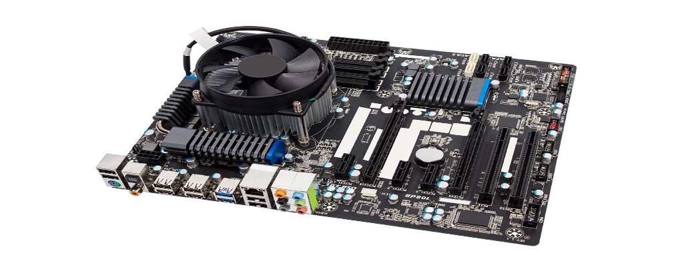

* The motherboard is the main component of a computer.
* The motherboard is at the center of what makes a PC work.
* It is a board with integrated circuitary that connects the other parts of the computer including the CPU, the RAM, the disk drives (CD, DVD, hard disk, or any others) as well as any peripherals connected via the ports or the expansion slots.
* The integrated circuit (IC) chips in a computer typically contain billions of tiny metal–oxide–semiconductor field-effect transistors (MOSFETs).
* When choosing a motherboard, it’s important to check what hardware ports the motherboard supplies. The ports on the motherboard will also help you define what other hardware will be compatible with your computer, such as what type of RAM and graphics card you can use.
* Although the motherboard is just one piece of circuitry, it is home to another one of the most important pieces of hardware: the processor.

**2.CPU**

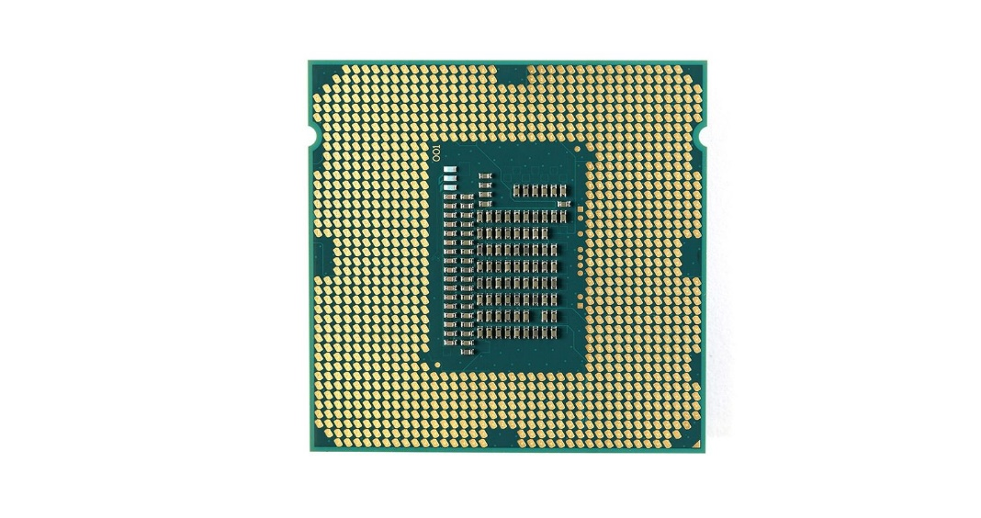

* The CPU (central processing unit), which performs most of the calculations which enable a computer to function, and is referred to as the brain of the computer.

* It takes program instructions from random-access memory (RAM), interprets and processes them and then sends back results so that the relevant components can carry out the instructions.
* The clock speed of CPU governs how fast it executes instructions and is measured in GHz; typical values lie between 1 GHz and 5 GHz.

* Many modern computers have the option to overclock the CPU which enhances performance at the expense of greater thermal output and thus a need for improved cooling.
* It is usually cooled by a heat sink and fan, or water-cooling system. Most newer CPU includes an on-die graphics processing unit (GPU).

**3.RAM**

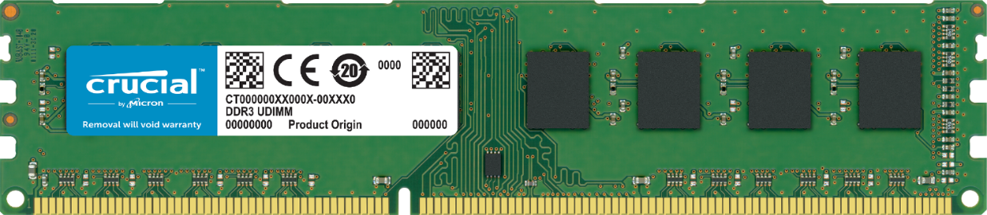

* Random Access Memory, or RAM, is hardware found in the memory slots of the motherboard.
* It stores the code and data that are being actively accessed by the CPU. For example, when a web browser is opened on the computer it takes up memory; this is stored in the RAM until the web browser is closed.
* It is typically a type of dynamic RAM (DRAM), such as synchronous DRAM (SDRAM), where MOS memory chips store data on memory cells consisting of MOSFETs and MOS capacitors.
* .RAM usually comes on dual in-line memory modules (DIMMs) in the sizes of 2GB, 4GB, and 8GB, but can be much larger.

**4.ROM**

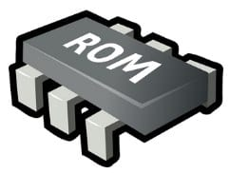

* ROM stands for a type of memory chip that can be read from but not written to.
* ROM is often used to store a computer's basic start-up instructions and certain types of data, such as your car's onboard computer system and a calculator's data tables.
* In other words, it's a form of data storage that can't be changed after being programmed.
* It's sometimes called "non-volatile" memory because the stored information will remain even when not powered up or in use.

**5.HARD DISK DRIVE**

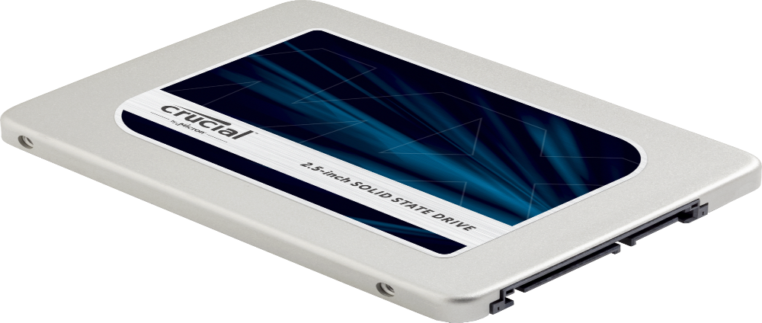

* The hard drive is a storage device responsible for storing permanent and temporary data.
* This data comes in many different forms, but is essentially anything saved or installed to a computer: for example, computer programs, family photos, operating system, word-processing documents, and so on.
* There are two different types of storage devices: the traditional hard disk drive (HDD) and the newer solid state drives (SSD).
* Hard disk drives work by writing binary data onto spinning magnetic disks called platters that rotate at high speeds, while a solid-state drive stores data by using static flash memory chips.
* As long as you have power, you can get to your things when you need them.
* You can think of it as "a closet" where all your stuff is stored safely.

**6.GRAPHICAL PROCESSING UNIT**

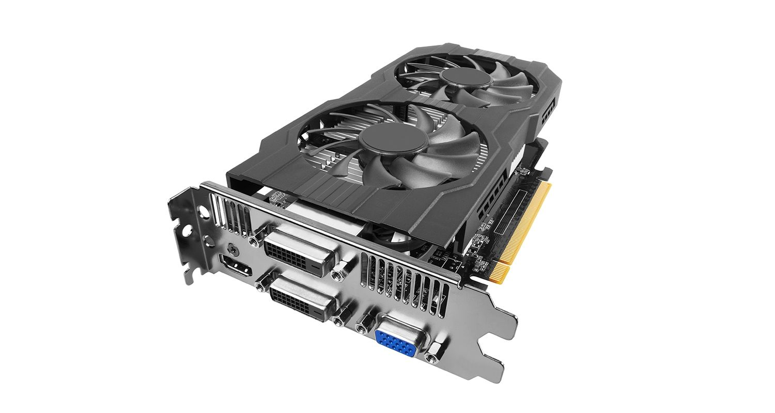

* Especially important for 3D rendering, the GPU does exactly what its name suggests and processes huge batches of graphic data.
* You will find that your computer’s graphics card has at least one GPU.
* As opposed to the basic on-board graphic capabilities that PC motherboards supply, dedicated graphics cards interface with the motherboard via an expansion slot to work almost exclusively on graphic rendering.
* you can upgrade your graphics card if you want to get a bit more performance from your PC.
* modern GPUs fulfil a broad computational workload beyond just rendering, making them an extension to the central processing unit.

## 7.  POWER SUPPLY UNIT

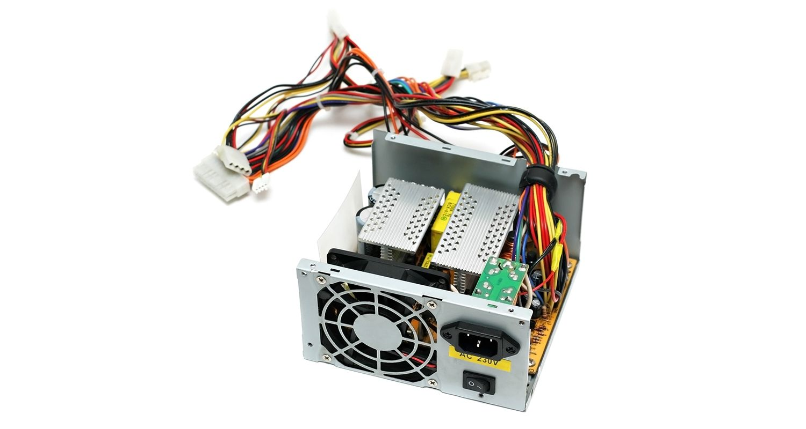

* A power supply unit, commonly abbreviated as PSU, does more than just supply your computer with power.
* It is the point where power enters your system from an external power source and is then allocated by the motherboard to individual component hardware.
* Computers that are used for highly intensive tasks such as graphic design or gaming will require more powerful components and thus will need a bigger PSU to cater to this additional need.
* Without the right amount of power, components won’t be able to run effectively and the computer might experience crashes or simply fail to boot at all. It’s recommended to have a power supply that more than covers your system usage.
* Understanding your computer and its hardware components can prove very useful when the time comes to upgrade or replace any parts, or when building a computer.

**8.OPTICAL DISK DRIVE**

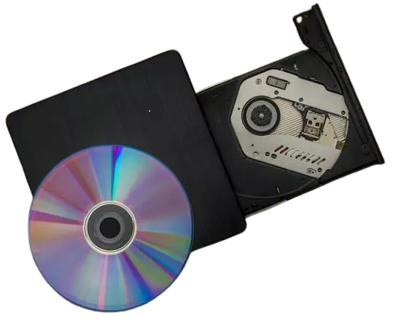

* Optical Drives are used in PCs to read and write CDs and DVDs.
* The optical drive reads the data from the disc, which can then be transformed into a digital file that is readable by the computer.
* This makes it easy to backup files, play music or movies, or copy data from one disc to another.
* The term "CD" refers to Compact Discs, which are the most common type of optical drive on modern computers.
* They are often used for installing software on your computer, moving data between computers, or writing new programs.

**9.EXTERNAL PORTS**

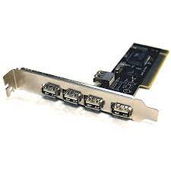

* External ports are used to connect your computer to other devices like printers and speakers, among many others
* Not all external ports are the same. You’ll find different types of ports on laptops and desktops that allow you to use them in different way

**10.SOUND CARD**

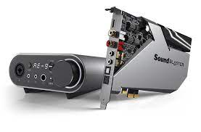

* A sound card is a computer chip that processes and amplifies sounds.
* It produces a signal to the speakers, headphones, or other output devices.
* The sound card can also be called a "sound card" or "audio card."
* Computers with sound cards are capable of playing digital music files and videos, as well as speech synthesis.
* Sound cards were originally provided as an external device for home computers in the 1980s.
* With the development of microprocessors, sound capabilities were integrated onto motherboards during the 1990s.
* Nowadays, most computers have these built-in.

**11.VIDEO DISPLAY CONTROLLER**

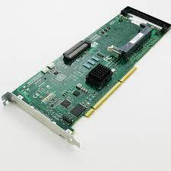

* Video display controllers (sometimes shortened to VDC) are circuits found in video cards, which control the video output of the computer.
* The controller is responsible for formatting the data that is sent to the monitor or TV.
* Video display controllers can be implemented by either an onboard circuit on the motherboard or a separate card that connects to the motherboard through a slot.